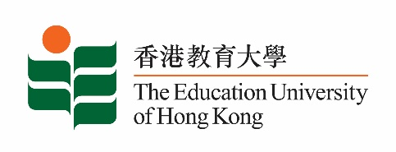
致： 傳媒機構採訪主任 (共 2頁) 17 December 2021
To : News Editors (total: 2 pages)

香港教育大學2021年12月20日至2022年1月2日可供採訪之活動一覽
The Education University of Hong Kong (EdUHK) Events Calendar for 20 December 2021 to 2 January 2022
本校誠邀 貴機構派員採訪下列活動。傳媒查詢，請聯絡教大傳訊處（電話：2948 6050）。
You are cordially invited to cover the events below. For media enquiries, please contact the Communications Office at 2948 6050.

因應2019冠狀病毒疫情，以下活動或有人數限制，傳媒請預先向主辦部門登記。
In light of the COVID-19 pandemic, there may be restrictions on the number of participants for the following event(s). Please contact the respective organiser(s) / department(s) for prior registration.

- 教大大埔校園 （新界大埔露屏路十號） / EdUHK Tai Po Campus (10 Lo Ping Road, Tai Po, New Territories)

日期  Date | 時間  Time | 活動  Event | 地點  Venue | 主辦部門及公眾查詢  Organiser &  Public Enquiry | 備註  Remarks
2021-12-10-  2021-12-30 | 10 am –  6 pm | STEAM教學設計及成果展  STEAM Teaching Design and Achievements Exhibition | 教大大埔校園  文化與創意藝術學系展覽廳(B2-P-01)  CCA Art Gallery, EdUHK Tai Po Campus (B2-P-01) | 主辦部門 / Organiser:  文化與創意藝術學系  Department of Cultural and Creative Arts  查詢 / Enquiries:  鍾小姐 Miss Zhong  電郵 / Email:  szhong@eduhk.hk  電話 / Tel :  2948 6883 | 免費入場，  敬請預約。  Free admission.  By appointment.  詳情/ Details:  https://www.facebook.com/eduhkcca/photos/a.806934382699416/4783467308379417/
2021-12-22 | 3 – 4 pm | FlipaClip網上工作坊  FlipaClip Online Workshop  主持 / Moderator:  黃素蘭博士  Dr Wong So-lan  導師 / Instructor:  嚴穎彤老師  Ms Rachel Yim Wing-tung | 線上講座  ZOOM  (連結將於報名後發送)  (Zoom link will be provided after registration) | 主辦部門 / Organiser:  文化與創意藝術學系  Department of Cultural and Creative Arts  查詢 / Enquiries:  鍾小姐 Miss Zhong  電郵 / Email:  szhong@eduhk.hk  電話 / Tel :  2948 6883 | 免費報名，歡迎各界人士參加。  Free Registration. All are welcome.  報名方法 / Registration:  https://forms.gle/piEm5AHbNWBREPHB6

